A tree’s shadow
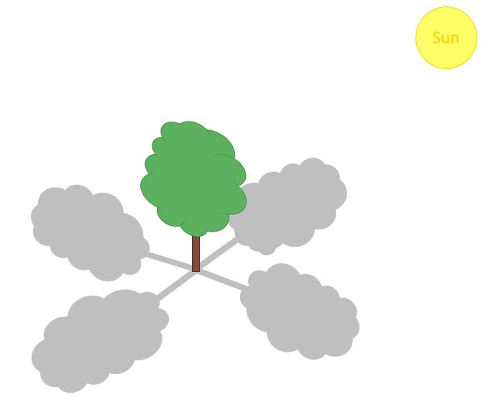
Matilda is sitting in the park.
She is looking at the shadow of a tall tree.

Where will she see the shadow?
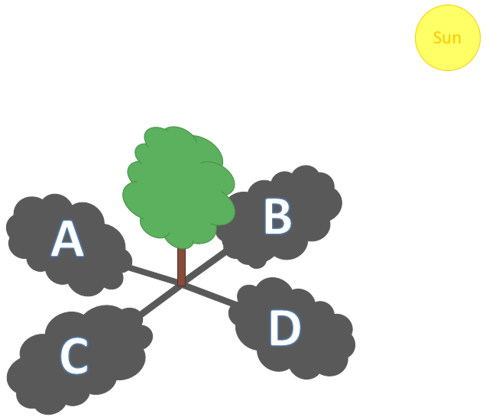

Physics > Big idea PSL: Sound, light and waves > Topic PSL1: Sound and light > Key concept PSL1.2: Characteristics of light
Diagnostic question
A tree’s shadow

Overview
Learning focus: | Light travels in straight lines at very high speeds.
Observable learning outcome: | Describe how light travels in straight lines.
Question type: | Simple multiple choice
Key words: | Light, travel, straight-line

P | PRIOR UNDERSTANDING  This diagnostic question probes understanding of ideas that are usually taught at age 5-11, to aid transition from earlier stages of learning.

What does the research say?
Students can think about light in linear rays without any idea of the movement of light along these rays (Guesne, 1985). They may think of rays as like ‘wires of light’ or roads going from A to B (Driver et al., 1994). In a study of 456 15-year-olds, Ramadas and Driver (1989) found that many students thought light rays were not like ordinary light, but described them variously as long, thin or flashing. These ideas are not helped by the fact that students cannot see the path light takes in normal circumstances.
This question checks whether students are thinking about ‘normal light’ travelling in a straight line.
Ways to use this question
Students should complete the question individually. This could be a pencil and paper exercise, or you could use an electronic ‘voting system’ or mini white boards and the PowerPoint presentation.
The answers to the question will show you whether students understood the concept sufficiently well to apply it correctly.
If there is a range of answers, you may choose to respond through structured class discussion. Ask one student to explain why they gave the answer they did; ask another student to explain why they agree with them; ask another to explain why they disagree, and so on. This sort of discussion gives students the opportunity to explore their thinking and for you to really understand their learning needs.
Differentiation
You may choose to read the questions to the class, so that everyone can focus on the science. In some situations it may be more appropriate for a teaching assistant to read for one or two students.
Expected answer
Shadow C
How to respond - what next?
In a study of ninety-four 10-11 year olds (Tiberghien et al., 1980) 66% gave the correct answer to this question.
80% gave either answer A or C. Answer C could be argued to be correct because of some ambiguity in the picture. They are showing a general understanding of how to place the light source, object and shadow in a straight line.
Those selecting B or D do not have a clear enough understanding of light travelling in a straight line to work out the correct answer from the picture.
If students are not able to select the correct shadow, it can help to demonstrate shadows that are made with a light source in a variety of different positions and asking students to predict where they expect the shadow to form. Careful questioning can lead to the understanding that the source, object and shadow are always in a straight line.
The following BEST ‘response activity’ could be used in follow-up to this diagnostic question:
- Response activity: Laser shadow
Acknowledgments
Developed by Peter Fairhurst (UYSEG), from an idea by Edith Guese in Light (1985).
Images: UYSEG
References
Driver, R., et al. (1994). Making Sense of Secondary Science: Research into Children's Ideas, London, UK: Routledge.
Guesne, E. (1985). Light. In Driver, R., Guesne, E. & Tiberghien, A. (eds.) Children's Ideas in Science. Milton Keynes: Open University Press.
Ramadas, J. and Driver, R. (1989). Aspects of Secondary Students' Ideas About Light, Leeds: University of Leeds Centre for Studies in Science and Mathematics Education.
Tiberghien, A., et al. (1980). Conceptions de la lumierechez l'enfantde 10-12 ans. Revue Francaise de Pedagogie, 50, 24-41.

